COMPUTER GENERATED IMAGERY (CGI): CASE STUDY

Name: Yash P. Nimbalkar

Roll No.:23327

Division: SE11

Subject: Computer Graphics (CG)

* **What is Computer-generated imagery (CGI)?**
* **Computer-generated imagery (CGI)** is the use of computer graphics to augment or create images in art and media.
* These can be 2D or 3D animations, objects, or renderings in a film, television program, video game, or simulation.
* CGI can be used in films ranging from science fiction epics to quiet intimate dramas.
* How the CGI is used varies, from animating entire locations to subtle work on props or environments. In recent years, CGI has been the go-to visual effect for most major movies, whether its use is subtle or obvious.
* **What is Computer-generated imagery (CGI)?**
* Two-dimensional imagery such as text, objects, backgrounds, and environments.
* Three-dimensional objects, including figures, spaces, and environments.
* When successful, it creates composite imagery that tricks the eye into believing in the illusion presented.
* When unsuccessful, it creates obviously fake imagery that shatters the illusion presented.
* **How did CGI evolve?**
* For those who want a chronological list you can read the [timeline of CGI in film and television](https://en.wikipedia.org/wiki/Timeline_of_computer_animation_in_film_and_television). For the rest of you, I've pulled out what I believe are the most notable milestones that contributed to the evolution of CGI.
* The history of CGI goes back to the 1950’s, when mechanical computers were repurposed to create patterns onto animation cells which were then incorporated into a feature film. That first film which used CGI was Alfred Hitchcock’s [Vertigo](https://en.wikipedia.org/wiki/Vertigo_(film)) (1958).
* A few years later CGI took another leap forward with the help of Hollywood. In 1973 Westworld flexed its muscles with the first 2D CGI scene showing ["Gunslinger" vision](https://www.youtube.com/watch?v=5jCDQvNh85Y) - an interpretation of how robots could see. The movie was so successful that it inspired a sequel.
* [The Trench Run Briefing in Star Wards: A New Hope](https://youtu.be/41PMJoeIDos) showed a wireframe rendering of the Death Star designed to help give the Rebel Alliance some last-minute training.
* It took years for computers to fully harness the power of CGI and to allow directors to bring their visions to life. By the end of the ‘70s, computer-generated imagery started popping up in a few science fiction movies such as [The Black Hole](https://www.youtube.com/watch?v=qzUJJKDa558) (more wireframe goodies) and [Alien](https://www.youtube.com/watch?v=bit-vYWVIdo) (another wireframe).
* CGI continued to really push the boundaries of computer power in the '80s - how good was [The Last Starfighter (1984)](https://en.wikipedia.org/wiki/The_Last_Starfighter) and [The Abyss (1989)](https://en.wikipedia.org/wiki/The_Abyss) - and more companies jump in to try their hand at this mesmerising mix of technology and art.
* 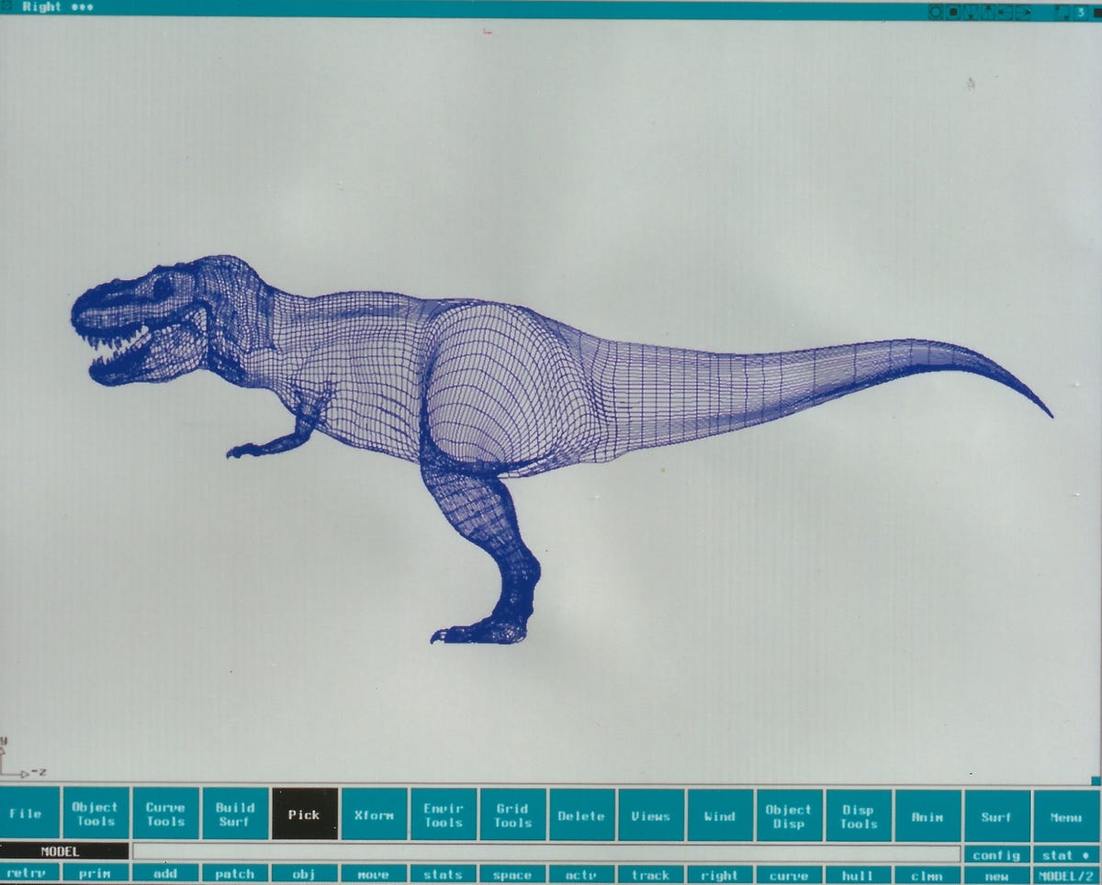In the '90s, computers allowed CGI masters to start really going big with their ideas and new found techniques. During this decade, countless ground-breaking films were released such as [Terminator II; Judgment Day (1991)](https://en.wikipedia.org/wiki/Terminator_2:_Judgment_Day), [The Lawnmower Man (1992),](https://en.wikipedia.org/wiki/The_Lawnmower_Man_(film))[Toy Story (1995)](https://en.wikipedia.org/wiki/Toy_Story), [Star Wars Special Editions](https://en.wikipedia.org/wiki/Star_Wars)  .
* Leading the charge with many of these movies was ILM, [Stan Winston Studios](https://nofilmschool.com/tags/stanwinston) and[Phil Tippet](https://nofilmschool.com/2017/05/watch-meet-mad-god-who-creates-stop-motion-masterpieces-frame-frame) who dropped arguably the best CGI of all time -  Jurassic Park (1993).
* 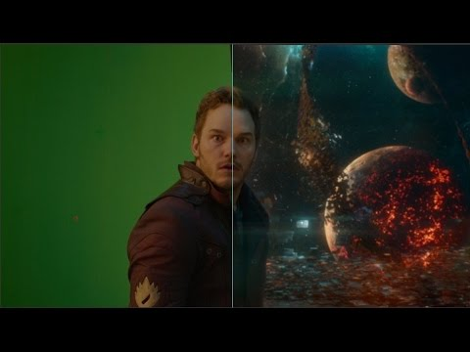By comparison today, one of the most successful films of all-time, [The Avengers](https://en.wikipedia.org/wiki/Avengers:_Endgame), has over 2,200 visual effects shots with CGI. Adding to this, 90 minutes of Transformers: Age of Extinction’s running time has CGI effects. Even the widely acclaimed [Guardians of the Galaxy](https://www.denofgeek.com/us/movies/guardians-of-the-galaxy/237863/guardians-of-the-galaxy-review) relied on CGI for 2,750 of its shots. In other words, 90 percent of Guardians features CGI in some capacity.
* What is the key role of CGI in following fields?
* **Art Department:**

The Art Department is responsible for translating a Directors vision and a script into visuals that can be shared with the entire team to truly understand the creative and technical challenges that lay ahead. These concept artists and illustrators create everything from storyboards to photorealistic artworks that show that how the final finished art will look like.



* **Pre-viz:**

Pre-visualisation Artists are responsible for creating the first 3D representation of the final visual effects shot. They use artwork and basic 3D models to create normally low-quality versions of the action sequences so the Director can start planning out camera placement and creative/technical requirements.

* **Asset Department:**

Virtual assets are need in visual effects to match real world objects or create new objects that don't exist or are too expensive to build in the real world. These are created by modeling artists and the experts in arts like **texture**painters,**shader**developers and**riggers.**

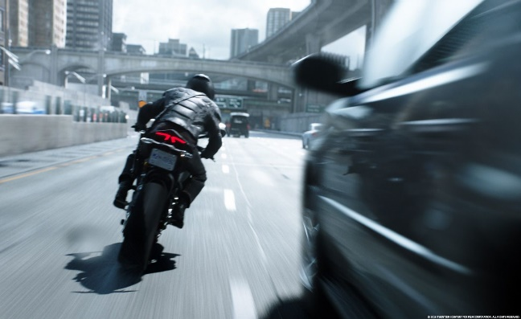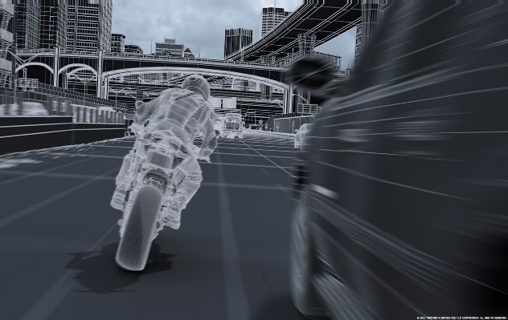

* **Research and Development:**

Considered a very technical department, RnD artists are responsible for building new software and tools to accomplish the tasks that can't be done, or are simply too time consuming for artists to manually complete over and over again. The role requires a very strong background in computer science and problem solving.

* **Animation:**

This one is pretty obvious. Basically, anything that moves on film needs to be animated. It doesn't matter if it's a small prop like a chair, a huge space ship or even a hero character or creature. If it moves and has a performance, an animator will most likely be behind the controls.

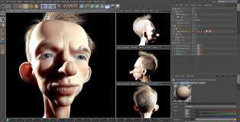

* **Matchmove:**

This is also referred to as motion tracking and without it there would be no way to incorporate 3D data into live action footage. To make digital assets appear as if they completely real, you need a virtual camera that moves exactly like the camera in the live action footage. This is where matchmove artists come to the rescue. It's their job to use the live action video footage and create a virtual camera for all departments to work with.

* 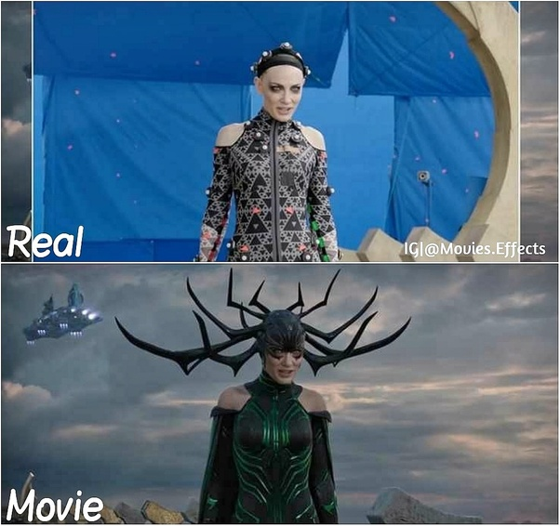**FX Simulation:**

An FX Artist designs and creates FX animation, procedural simulation, dynamic simulation, and particle and fluid systems. They are responsible for recreating the behaviour of real-world elements such as fire, water, explosions, cloth, hair and a whole lot more that most people don't even realise. Highly technical, yet creative role.

* **Lighting:**

The lighting artist is responsible for applying all lighting effects to the digital scene. The artist takes into consideration the light sources of the live-action plate and applies virtual lighting to mimic the existing illumination within the environment. The goal is to ensure that the VFX and live-action elements blend seamlessly, as though both exist in the same environment.

* **Matte paint:**

A matte painting is an image, created using digital or traditional painting techniques, to create a representation of a scene that would be impossible for filmmakers to deliver in real life. This might be because the landscape does not exist in the real world, it's not financially practical to travel to a location, or to extend the set outside of its filmed parameters.

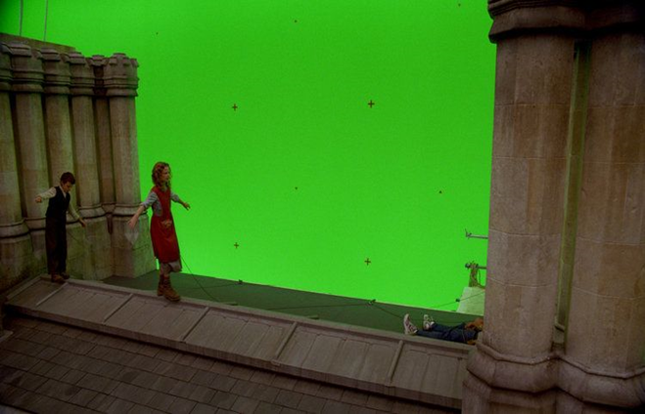

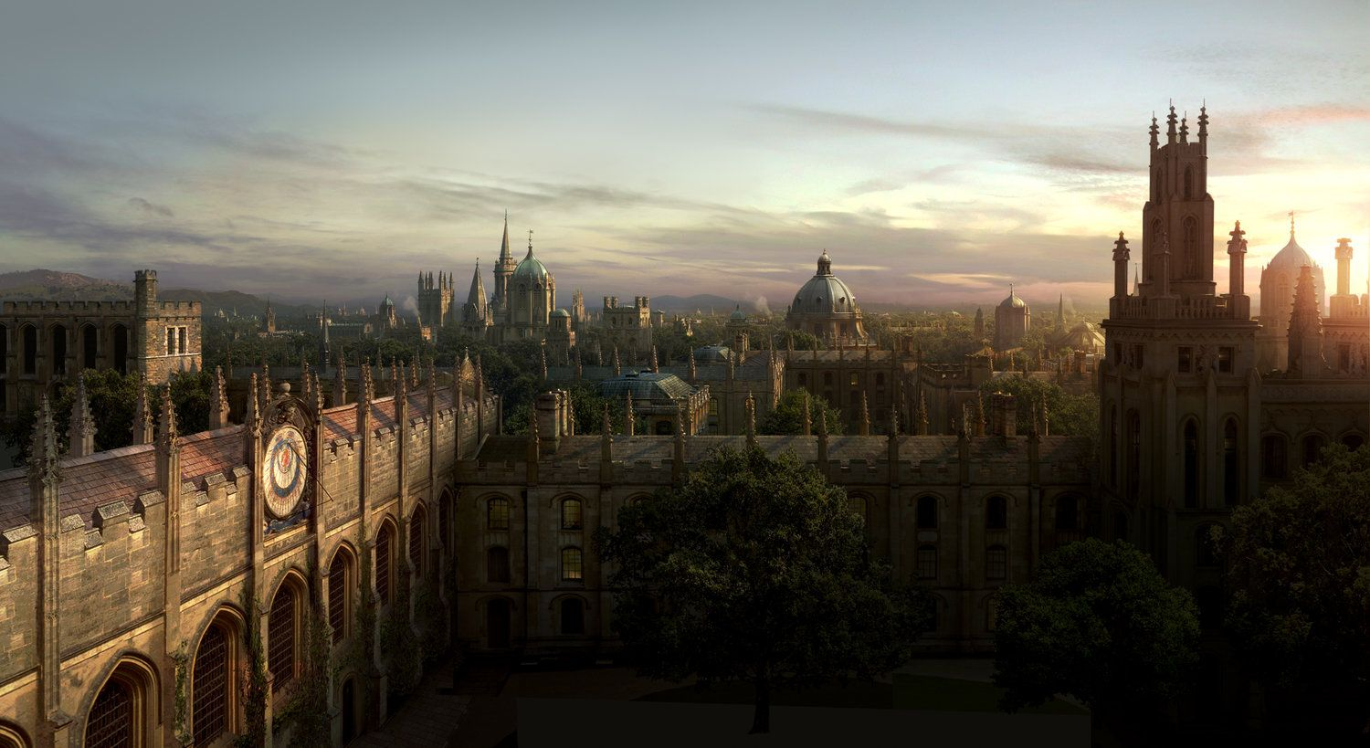

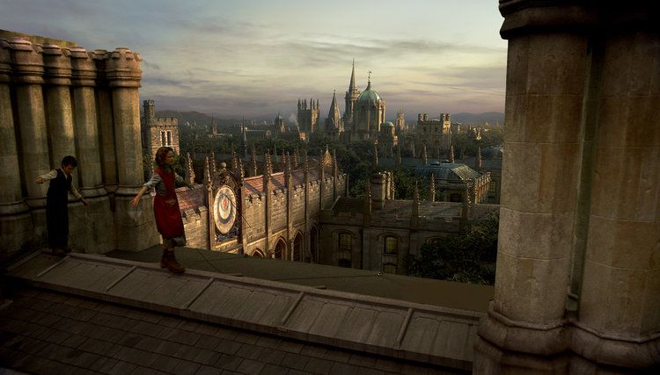

* **Rotoscoping:**

Rotoscoping is used to create a matte or mask for an element so it can be extracted out of place on a different background, masked out so colour can be changed or any other set of reasons. The rotoscoping artist will normally trace an object using a set of tools to create a new alpha channel for a specific part of an image sequence or video.

* **Compositing**

Compositing is the action of layering all the various elements in a shot – live action, mattes, multiple CG passes, 3D lighting, animation, particle effects – and blending them all seamlessly to create the photo-realistic final shot. Working throughout the production process, you’ll need to collaborate with other VFX departments to creatively and technically problem solve along the way.

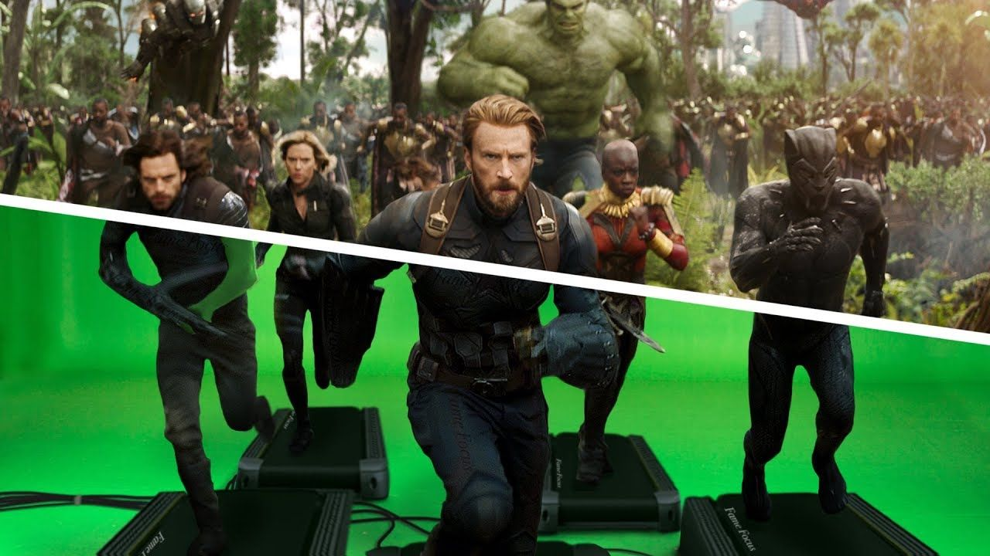

* **Production:**

There are also a number of roles for people who prefer managing teams, budgets and schedules. The top production role at a studio is the VFX Producer who works closely with the VFX supervisor to project manage the entire process, defining the resources required, hiring artists and crew, managing budgets and making sure the project is delivered on schedule. Other common roles include Production Manager and Production coordinator which support the Producer by liaising with artists, flagging issues and generally tracking progress and making sure everything stays on track from a scheduling perspective.

#scheduling #management #budgets #glue

* What conclusions do we draw?
  + CGI technology now has a lead over other special effect methods. It is because CGI is safer, cost-friendly and allows the filmmakers to have greater control over a production. It is safer and time effective to shoot in a controlled environment with CGI and the filmmakers can also create any fantastic story in different ways with non-existing real-life characters that no one can ever imagine to enhance the quality of the story.
  + As conclusion, CGI is the symbol of future in film industry. CGI started with animation as simple as deformation and reformation but has come to the point where feature length films rely on CGI to make the dreams and stories of director into reality.
  + Today, we can even make movies entirely comprising of CGI. As technology continues to progress, so will CGI and the techniques used to capture the object from the real world and render them in the computer-generated worlds of film.